Odoo Contacts – User Guide

Contents

Purpose 1

Odoo Contacts 1

Extending Partner Records 1

Definitions 2

Creating a Partner 3

Form Tabs 4

Contacts and Addresses 4

Internal Notes 4

Agreements 5

Sales & Purchases 5

Accounting 5

Partner Assignation 6

Field Service 6

Creating a Location Contact 6

# Purpose

The purpose of this document is to describe the Partner structure in Odoo and how it’s used for the company’s processes.

# Odoo Contacts

Odoo is built around the partners module and the Contacts app is one way to access these records. As with any ERP, they are all centered around customer accounts and contacts and Odoo is no different. A contact (also known as Partner) is extremely flexible and contains companies, individuals, vendors, shipping and billing addresses.

# Extending Partner Records

To understand the structure, it’s important to understand how the Odoo Modules interact with each other. Many other apps expand the partners module, extending the functionality of the system. When creating a new system user for example, a partner record will also be created since it’s an extension of the partner record. Same with the Field Service Locations and Workers, which both are extensions of the Partner record. These extended modules inherit the partner module therefore they inherit the fields of the partner module, so even though they contain their own records, the linked partner records fields are also linked. For example, when the user records address is updated, it’s also reflected on the partner record.

If an extended module has a record created within it, a partner record will always also be created.

* A partner record won’t always have an extended record
  + A customer won’t always have a Field Service Location record
  + A vendor won’t always have a Field Service Worker record
* An extended record will always have a partner record
  + Example 1, a Field Service Location will always also have a partner record.
  + Example 2, a system user will always also have a partner record.

# Definitions

The term Contacts and Partners are used interchangeably and references the same records in Odoo. Partner is used more often since the records can represent a wide range of types. Since the Partner module is home to many different categories of records, it’s important to define the primary ones.

* **Partners**
  + When creating a partner record, it must be set to one of the following:
    - **Company** – A partner record marked as a Company, typically meaning an organization.
    - **Individual** – A partner record marked as an Individual, typically meaning a person.
  + Each partner record then can be configured to be part of:
    - **Vendors** – Anyone who can provide goods or service.
    - **Customer** – Anyone who can purchase goods or services.
    - **Contacts & Addresses** – An additional address linked to a parent partner record.
      * **Contact** – An individual who is part of the company, or directly related to the parent record. Typically, Employees. They usually have the same address and information as the parent record.
      * **Shipping Address** – Specify a different shipping address if different than the main address.
      * **Invoice Address** – Specify a different invoicing address if different than the main address.
      * **Other Address** – Another way to create a different address for special circumstances.
      * **Private Address** – Can be a contact that’s linked to the company, however, will have its own address information and doesn’t inherit the parents address information.
* **Users**
  + Users are an extension of the partner record.
  + Users have three types
    - **Internal** – A paid licensed system user that has direct access to Odoo
    - **Portal** – A partner who has been granted access to Odoo’s customer portals and has very limited permissions (Only can read their own records and transactions like invoices, payments, etc.)
    - **Public** – A partner which does not has the login access but can read the info published on website, is public user.
* **Locations**
  + Locations are an extension of the partner module and represent locations that are provided services and/or support.
  + Separating the locations from the partner structure gives flexibility for when ownership changes and keeps transactions and reporting clean.
  + Locations have their own linked partner records
    - **Related Owner** – The partner who owns the location.
    - **Billed Customer** – The partner who will be billed at the location.
    - **Primary Contact** – The partner who is the primary contact for the location.
  + Locations can have sub locations creating a hierarchy. (Buildings/Floors/Units)
  + Locations can have equipment linked to them

# Creating a Partner

Depending on what you do in your department, the partner records can be accessed within many apps in Odoo. For example, the Field Service app has a menu item to open the partners, as well as the CRM and Sales apps. Once you are on the list of partners, you can create a new record.

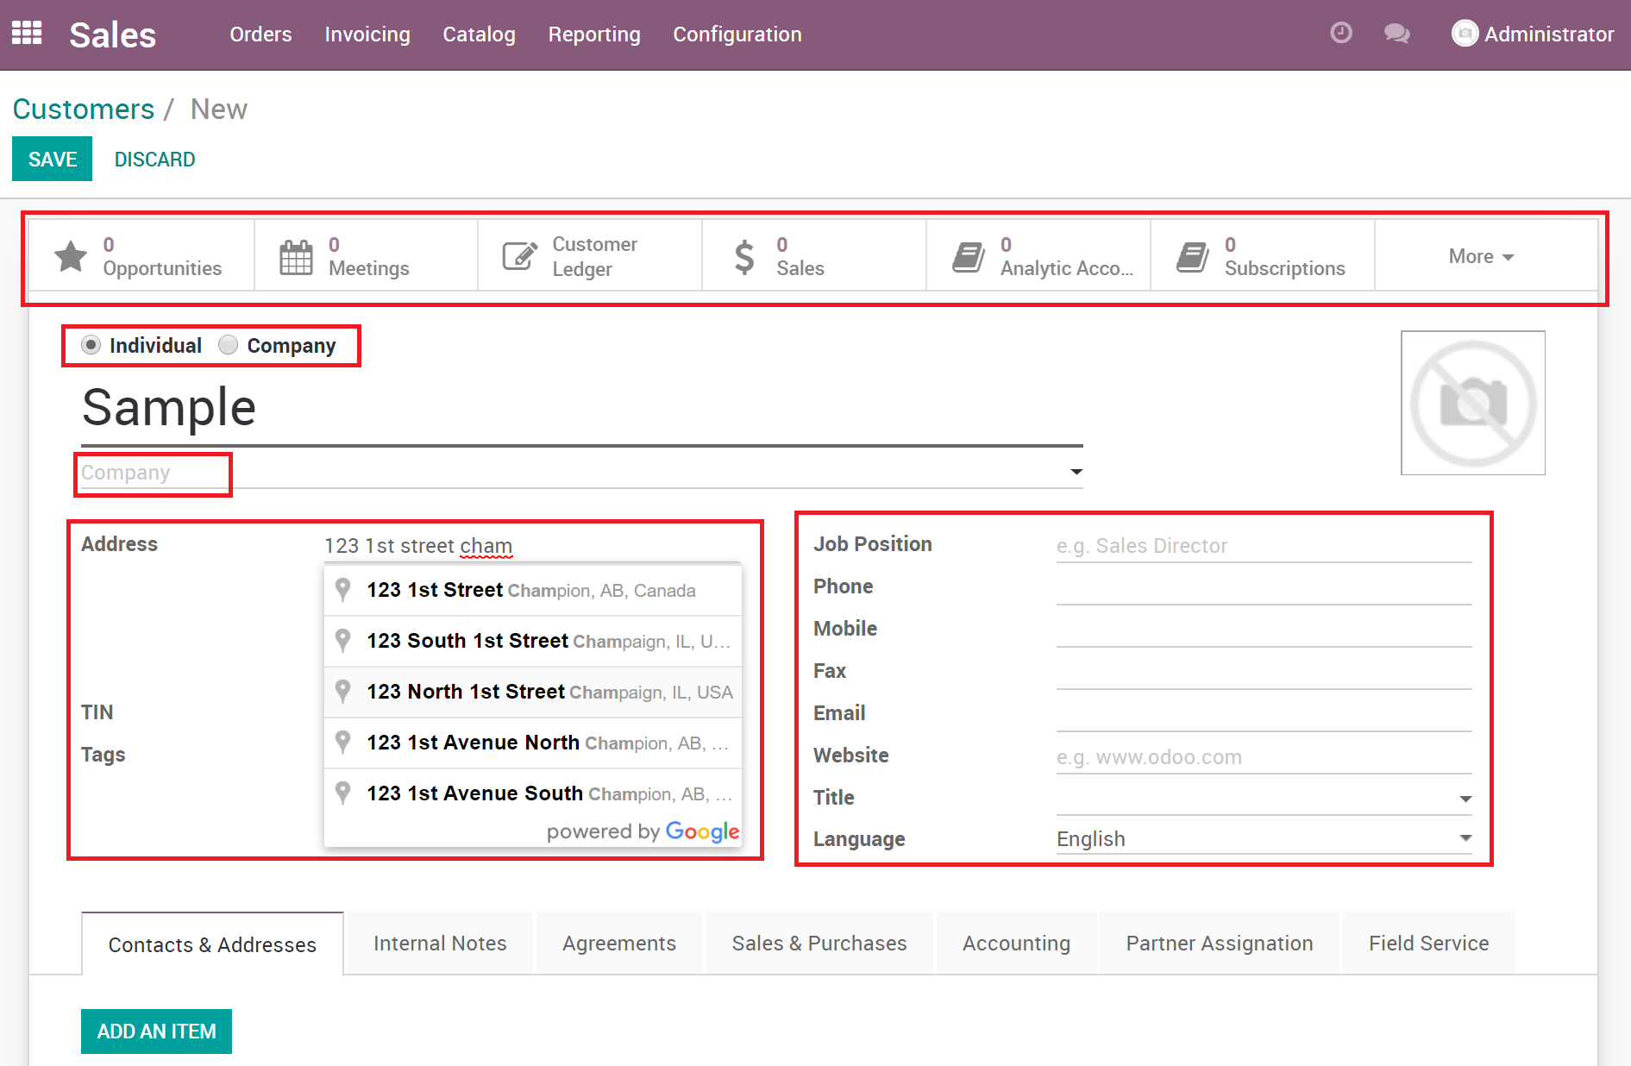

The Partner form has a lot of information described as:

* **Smart Buttons**: Located at the top of the form, these give quick access to records related to the partner. The smart buttons only show if the partner configurations are set to be linked to them. Example, if the partner is not marked as a customer, you wouldn’t see customer ledger, sales, subscriptions, etc.
* **Individual or Company**: This selection describes if this partner is an individual or a company.
* **Address**: Address normalization is enabled and uses google to assist the user with selecting the properly formatted address.
* **TIN**: Taxpayer Identification Number.
* **Tags**: Tags add the ability to categorize partner records.
* **Job Position**: Provides the ability to describe the persons job position.
* **Phone:** Primary phone number.
* **Mobile:** Mobile phone number.
* **Fax:** Fax number.
* **Email:** Email address.
* **Website:** Partners website.
* **Title:** If title is needed, Mr. Mrs.
* **Language:** Odoo is a multi-language system, therefore the customers can view the portals in the language that is selected.

## Form Tabs

Multiple tabs will contain additional relevant information. Their purpose is to keep fields organized and typically additional tabs are added as modules are installed.

### Contacts and Addresses

This is where directly related contacts and additional addresses are added.

1. Click the **Contacts & Addresses** tab.
2. Click the **Add an Item** button.
3. Select the appropriate type of record.
4. Depending on the selection, different fields will be shown. Enter the required information.

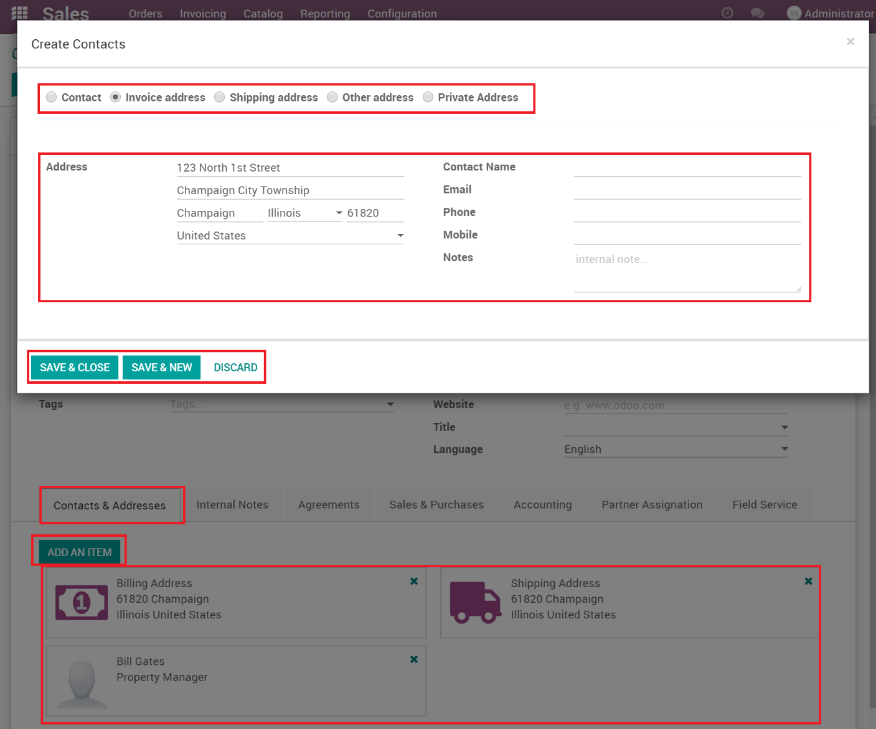

Once saved, the new records show in the tab area.

### Internal Notes

Internal notes can be added in there. Also, warnings can be enabled in Odoo and when they are, the ones pertaining to partner records show in the Internal Notes tab.

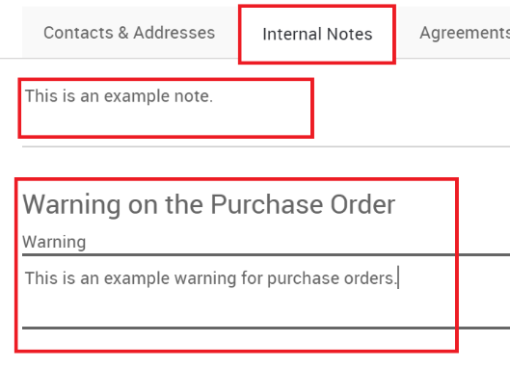

### Agreements

With the Agreement app installed, the agreements tab will show any linked agreements for the partner.

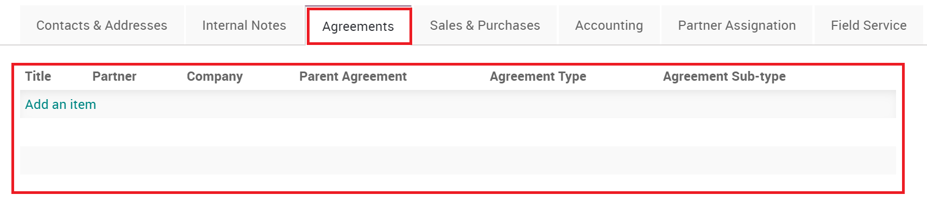

### Sales & Purchases

The Sales & Purchases tab fields related to the sales and purchasing apps. This is where you select whether this partner is a Customer, Vendor, who the salesperson is, default delivery methods, sales pricelists, etc.

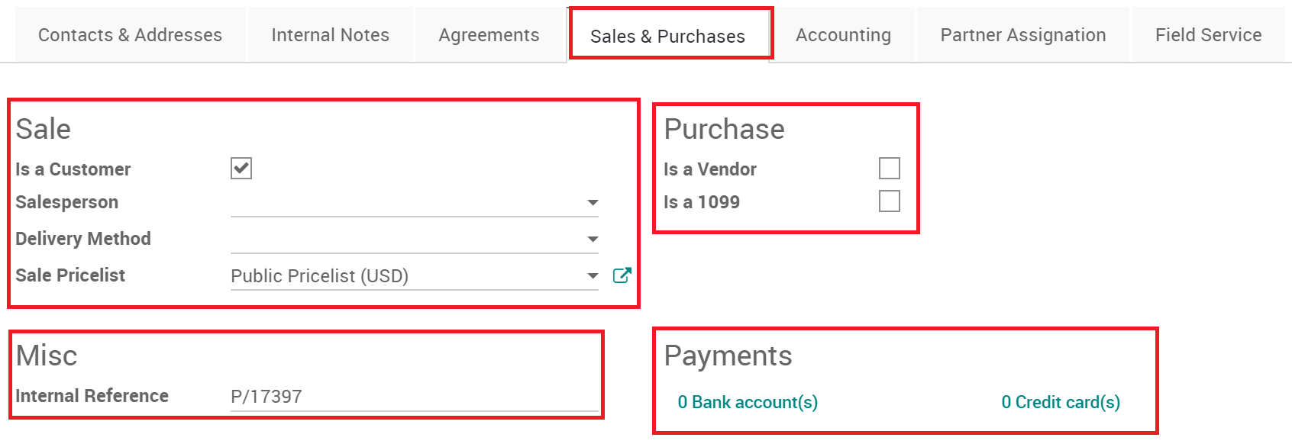

### Accounting

The accounting section extends the sales and purchasing apps to contain more information specific to accounting.

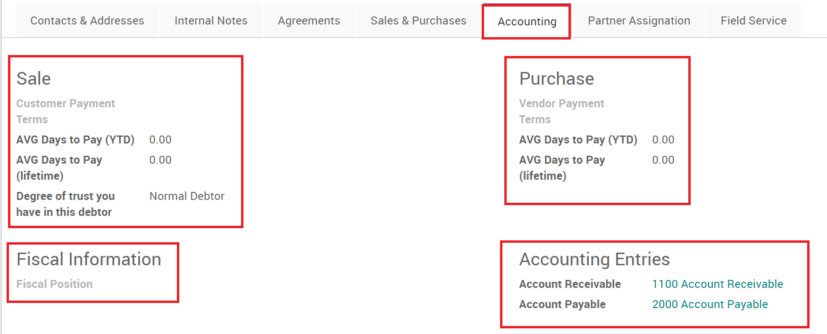

### Partner Assignation

The Geolocation app adds this tab and adds the ability to geocode latitude and longitude based on the main address. This is used heavily by the Field Service app.

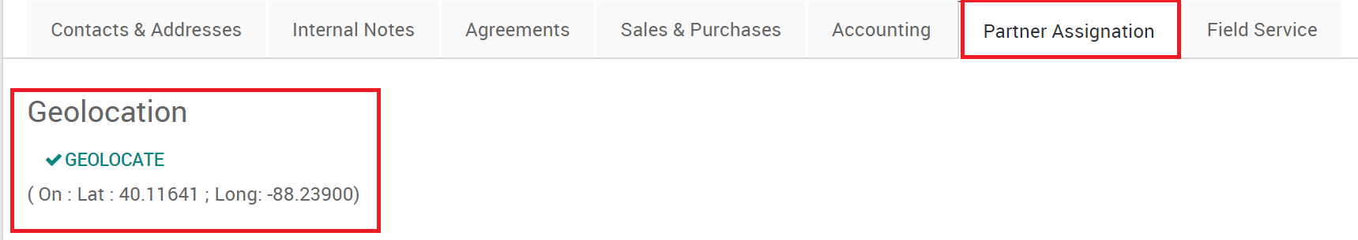

### Field Service

The Field Service app adds several fields to the partner record. When the partner is converted to a Location or Worker, the check box fields are filled in, this must be done via an action. The Primary Service Location is used to link this partner (contact) to a location.

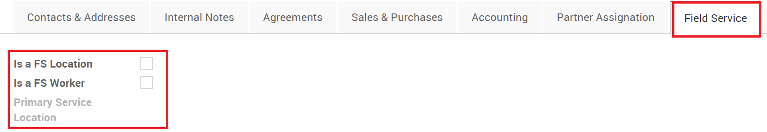

# Creating a Location Contact

A location is someone who lives at a location. They aren’t part of the company but are a resident or tenant that lives at the property. We create them slightly differently than an employee or someone directly related to the parent company.

1. In the Field Service App, go to **Master Data**/**Locations**

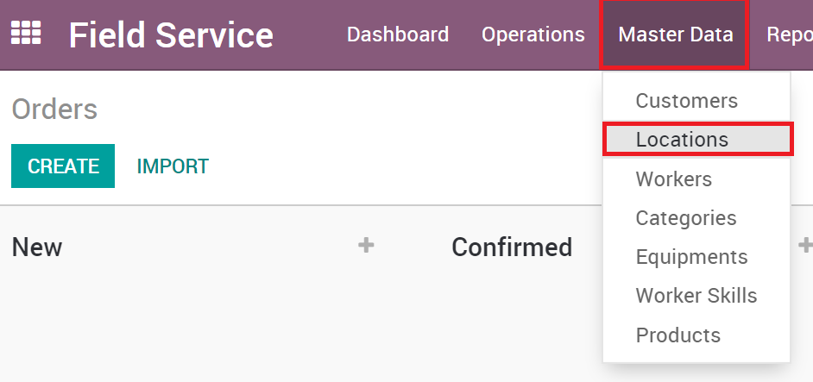

1. Open the **Location**
2. Click on the **Contacts** Smart Button

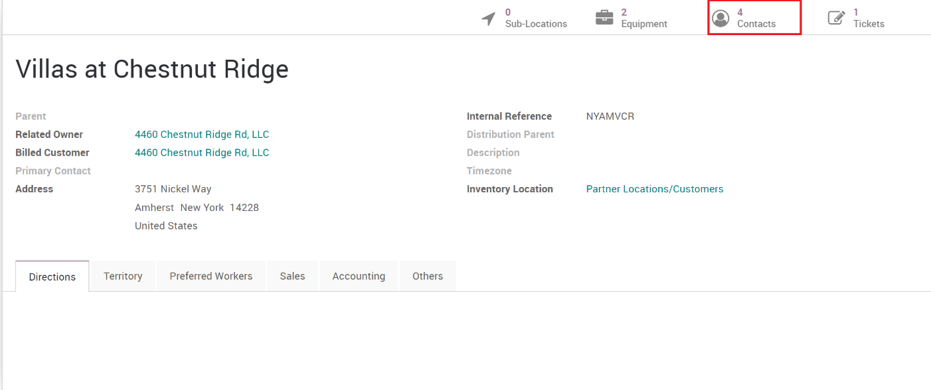

1. You will see all the contacts for this location, click **Create**
2. The rest is the same as above by creating an individual partner record and filling in all the relevant information.